**Supplementary Information to “Predicting Mechanical Properties of Non-Equimolar High-Entropy Carbides using Machine Learning”**

Xi Zhao*a,b\**, Shu-guang Cheng*a*, Sen Yu*b*, Jiming Zheng*a*, Rui-Zhi Zhang*c*, Meng Guo*c*

*a School of Physics, Northwest University, Xi'an 710069, China*

*b Northwest Institute for Nonferrous Metal Research, Xi’an 710016, China*

*c Jinan Key Laboratory of High-Performance Industrial Software, Jinan Institute of Supercomputing Technology, Jinan, Shandong 250103, China*

* Corresponding author: [zhao_xii@stumail.nwu.edu.cn](mailto:zhao_xii@stumail.nwu.edu.cn)

**S1 – The crystal structures for high-throughput density functional calculations of elastic properties for 495 carbides and 123 high-entropy carbides**

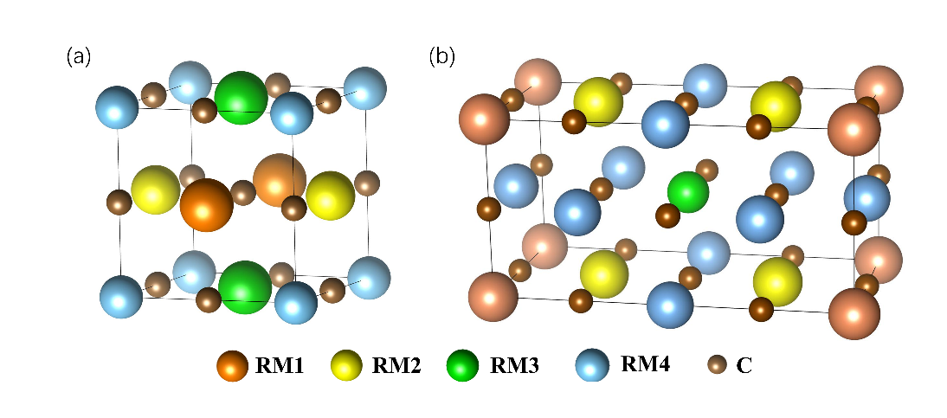The crystal structure (left) used for the calculation of the elastic properties of 495 carbides is a single-phase salt rock structure with 8 atoms, and the crystal structure (right) used for the calculation of the elastic properties of 123 high-entropy carbides is a 2x1x1 single-phase salt rock structure containing 16 atoms. For all calculation structures, transition metal atoms Ta, Zr, Hf, V, Nb, Ti, Mo, W, Cr occupy the cation sites and carbon atoms occupy the anion sites.

*Fig S1 Calculation structure for carbides and high entropy carbides*

**S2 –Detailed description of the 6 CBFV descriptors**

*Table S2．Description and comparison of CBFV descriptors—Jarvis, Magpie, Mat2vec, Onehot, Oliynyk, Random*

|  |  |  |
| --- | --- | --- |
| **Descriptor** | **Description** | **Advantages** |
| **Jarvis** | A collection of feature descriptors used to characterize elements and compounds, including information such as the electronic structure, crystal structure, mechanical properties, thermodynamic properties, etc | Comprehensive description of material properties, suitable for diverse machine learning tasks |
| **Magpie** | A set of characteristic descriptors developed by Ward et al., based primarily on the physical and chemical properties of elements, including atomic radius, electronegativity, melting point, boiling point, etc., describes materials through statistical information of these properties (such as mean, variance, minimum, maximum, etc.) | Captures a wide range of element properties, providing useful statistical information. |
| **Mat2vec** | Based on natural language processing (NLP) descriptors, word embeddings are used to represent materials. Each material or element is represented as a multi-dimensional vector, which can be used for various machine learning tasks. | Capture the contextual information and implicit characteristics of the materials, useful for tasks requiring semantic understanding. |
| **Onehot** | Simple encoding method that converts discrete categories (element symbols) into numerical vectors with a length equal to the number of elements. | easy to implement, provides unique representation for each element. |
| **Oliynyk** | Based on physical and chemical properties such as atomic radius, ionic radius, electronegativity, melting point, similar to Magpie but with different feature selection and combination | Focus on more complex and diverse material properties, suitable for complex materials and sophisticated machine learning models |
| **Random** | Uses randomly generated feature vectors, does not rely on specific physical or chemical properties, often used for baseline comparison or exploratory analysis | Simple to generate, useful for baseline comparisons and exploratory analysis. |

**S3 – The elastic properties of monocarbides**

The elastic modulus of monocarbides is employed to calculate the ROM values of the elastic properties for 495 carbide systems.

*Table S3．The elastic properties of binary carbides*

|  |  |  |  |  |  |
| --- | --- | --- | --- | --- | --- |
| **Binary Carbide** | **Young’s modulus**  **(GPa)** | **bulk modulus**  **(GPa)** | | | **shear modulus**  **(GPa)** |
| ZrC | 393.59 | | 222.63 | 163.27 | |
| NbC | 436.19 | | 301.31 | 173.27 | |
| HfC | |  | | --- | | 452.36 | | | 254.57 | 187.88 | |
| TaC | |  | | --- | | 421.97 | | | 338.65 | |  | | --- | | 163.26 | | |
| TiC | 438.54 | | 266.74 | 178.85 | |
| CrC | 427.71 | | 338.28 | 165.87 | |
| VC | 556.30 | | 318.72 | 230.05 | |
| MoC | 436.19 | | 301.31 | 173.27 | |
| WC | 424.41 | | 381.01 | 161.45 | |

**S4 – The machine learning predicted elastic properties of 495 carbides with five kinds of composition-based feature vector descriptors**

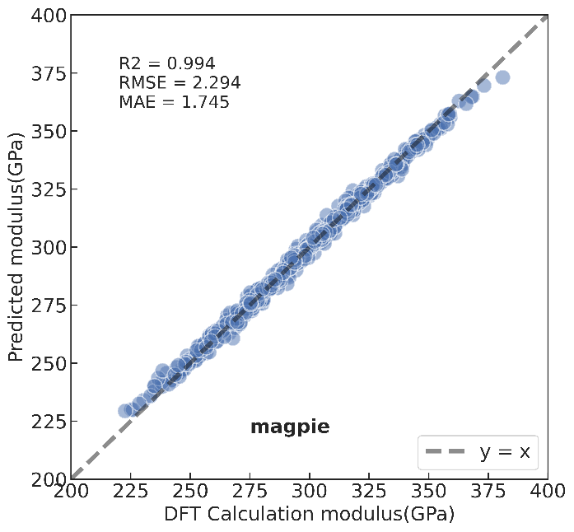

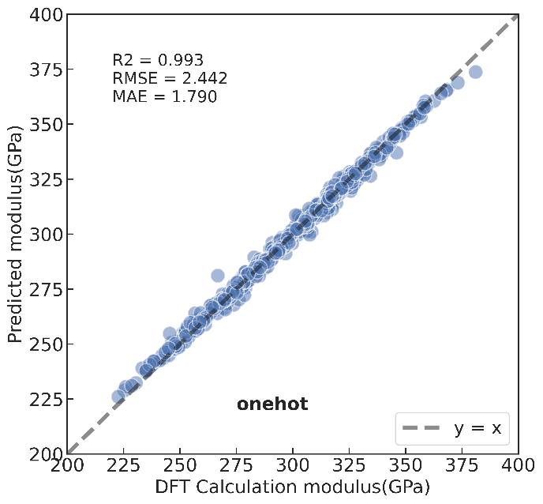*Fig S4 Machine learning prediction results with magpie descriptors*

*Fig S5 Machine learning prediction results with onehot descriptors*

*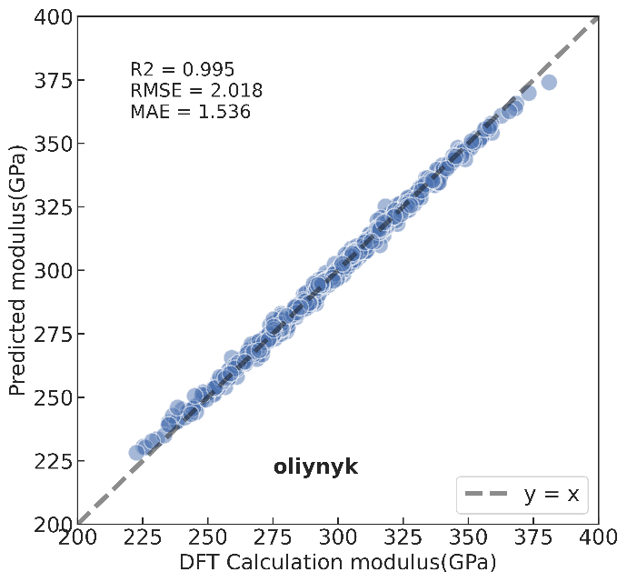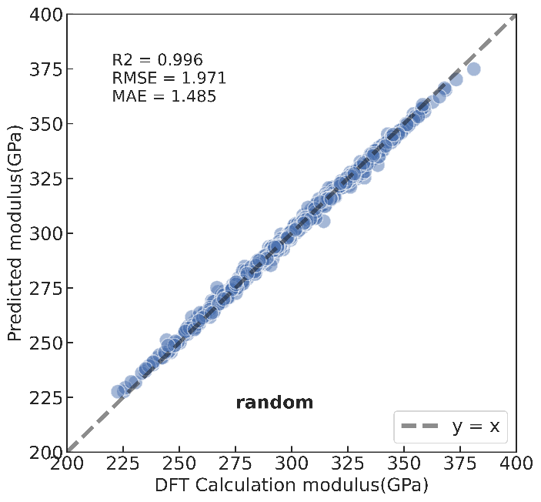Fig S6 Machine learning prediction results with oliynyk descriptors*

*Fig S7 Machine learning prediction results with random descriptors*

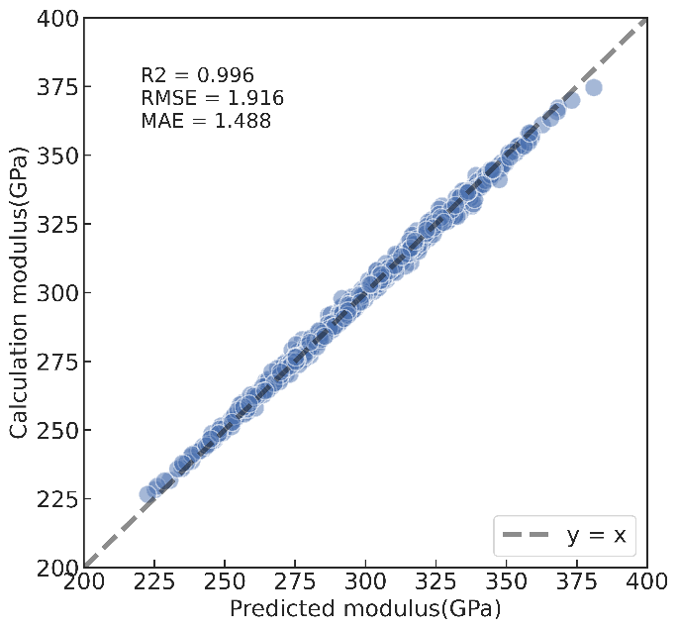*Fig S8Machine learning prediction results with mat2vec descriptors*

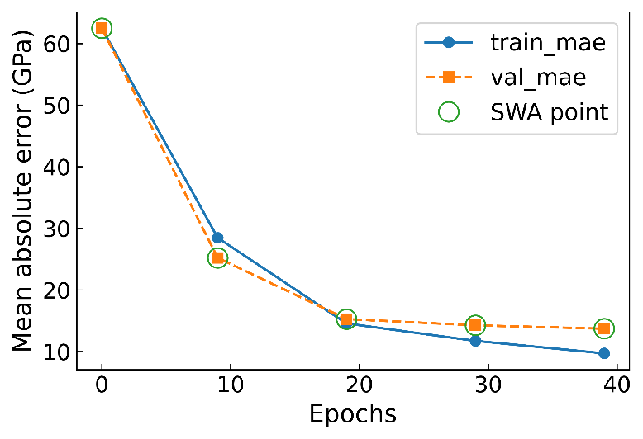**S5 –Results of Crabnet model predicting elastic properties**

*Fig S9 The changes in predicted Young’s modulus over the course of the optimization process against the mean absolute error*

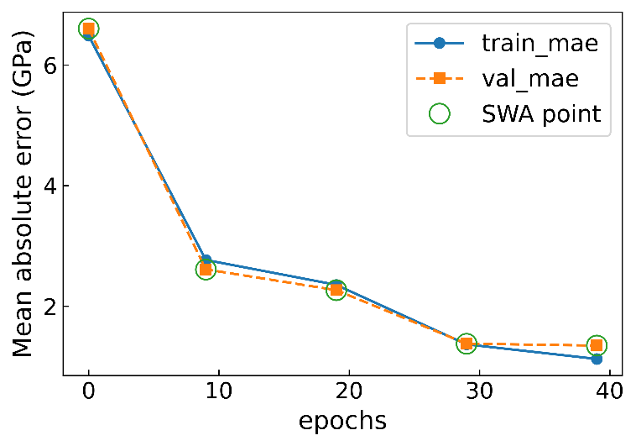*Fig S10 The changes in predicted hardness over the course of the optimization process against the mean absolute error*

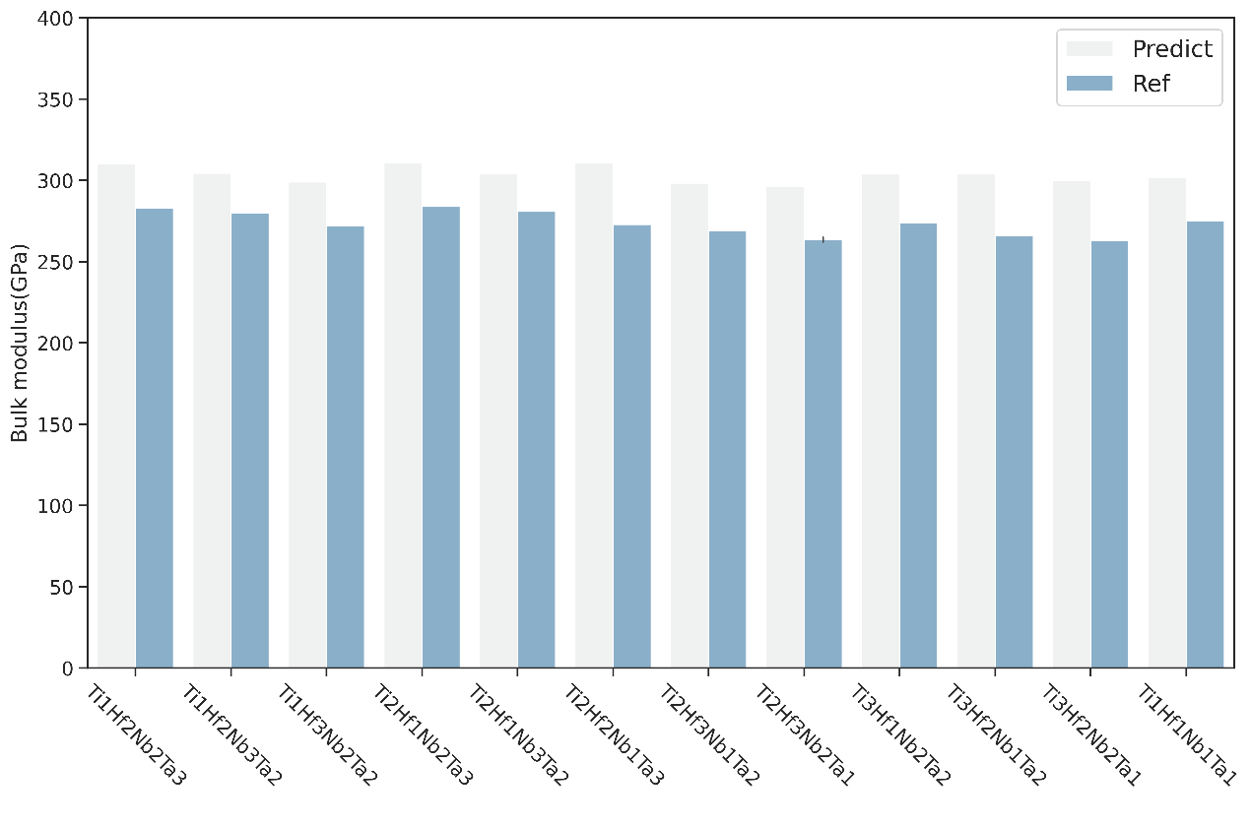**S6 –Comparison of Crabnet model prediction results with DFT results in Ref**

*Fig S11 Comparison of bulk modulus of 12 non-equimolar HECs calculated by DFT and predicted by Crabnet model*